*What is AJAX? What are the main characteristics of this technology? What are the existing standards that AJAX is based on? Explain how AJAX works.*

Ajax stands for “Asynchronous JavaScript And XML”. According to W3S (n.d.), there three main characters of Ajax; (1) Read data from a web server - after a web page has loaded, (2) Update a web page without reloading the page, and (3) Send data to a web server - in the background. As for the first character, when we watch the top page of YouTube and scroll it down to the bottom of the page, it loads the new lists of videos. What happens behind this is that JavaScript on the top page will send another HTTP request to web server to get responses instead of web browser or mobile application. As for the second character, Facebook web page is a good example. When user clicks the groups tab on the navigation bar, the presentation below the bar changes. It seems it loads the new HTML pages with full request, but the part changed is only the feed part. The rest of navigation bar stays as it is. Thus, the presentation part is changed by the AJAX request from JavaScript of existing page. These are how AJAX works. As for the standards of AJAX, as the image below from W3S shows, JavaScript creates XMLHttpRequest object when the event occurs.

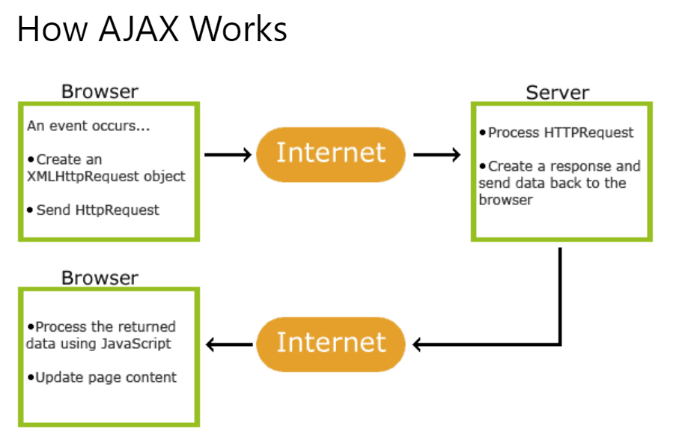

References:

What is AJAX? *w3schools.* Retrieved from  [https://www.w3schools.com/whatis/whatis_ajax.asp](https://www.w3schools.com/css/css_specificity.asp)